

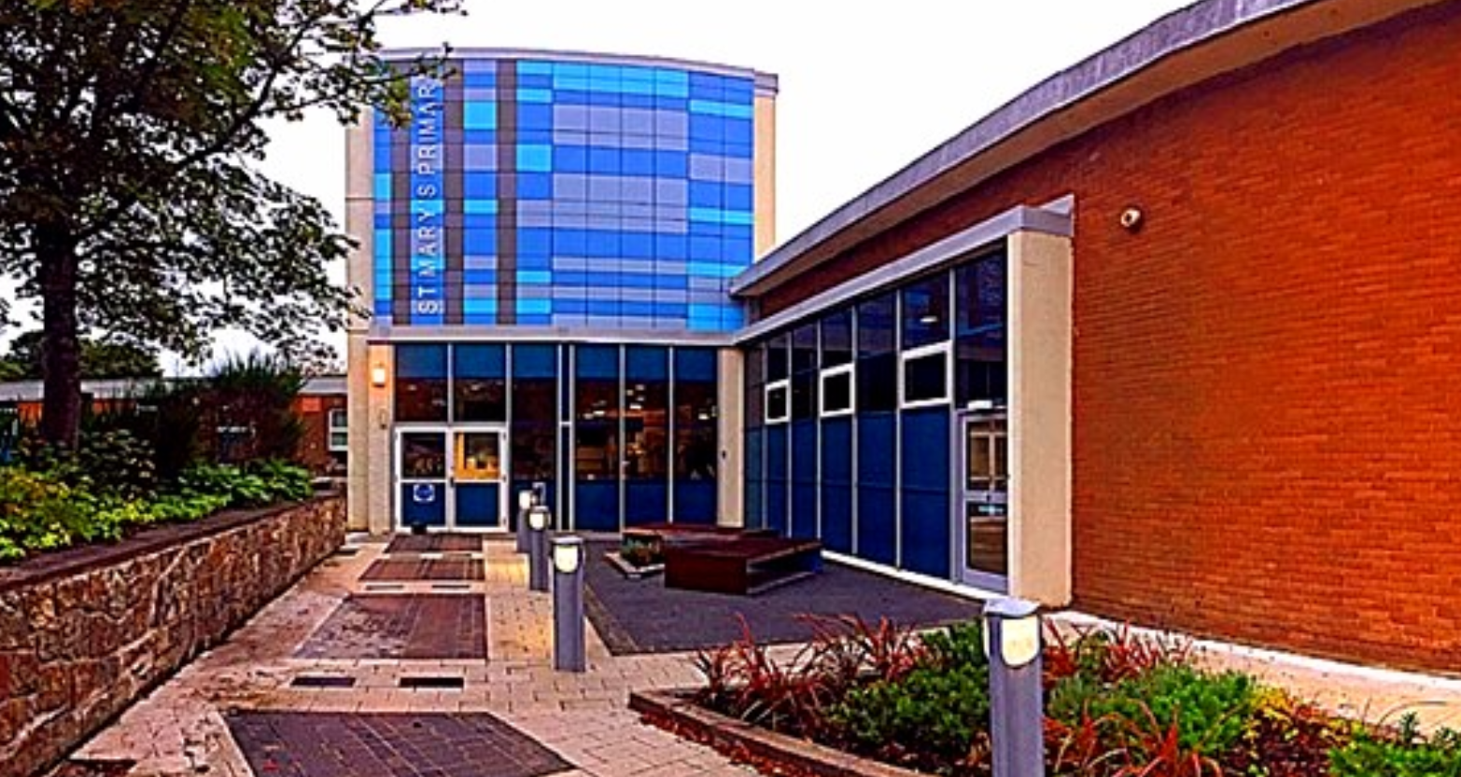
St Mary’s Primary and Nursery School Bathgate

contents

section 1 school information
West Lothian Council Mission Statement 1
West Lothian Council Values 1
School Aims 1
section 2 standards
  - Attendance 2
  - Ethos and Behaviour 3
  - School Dress Code 4
section 3 ethos
  - Equality and Fairness 5
  - Partnership and Communication with Parents 5
  - Parent Councils 6
section 4 curriculum
  - General 7
  - Instrumental Tuition 10
  - Use of the Internet 11
  - Assessment and Reporting 12
  - Support for Learning 12
section 5 admission procedures
  - Admission Procedures 13
  - New Entrants to P1 13
  - Transfer from P7 to Secondary School 13
  - Extra-Curricular Activities 14
section 6 health & safety and pupil welfare
  - Medication in Schools 17
  - Emergency Contacts and Arrangements 17
  - Meals and Milk 18
  - Security 18
  - Photography 19
  - Child Protection Guidelines 19
  - Playground Supervision 20
  - Transport 20
  - Car Park 20
  - Requested Early Release of Pupil 20
  - Data sharing 21
  - Concerns and Complaints 22

school information

West Lothian Council Mission Statement

“Striving for excellence…working with and for our communities.”

West Lothian Council Values

- Focusing on customers’ needs
- Being honest, open and accountable
- Providing equality of opportunities
- Developing employees
- Making best use of resources
- Working in partnership

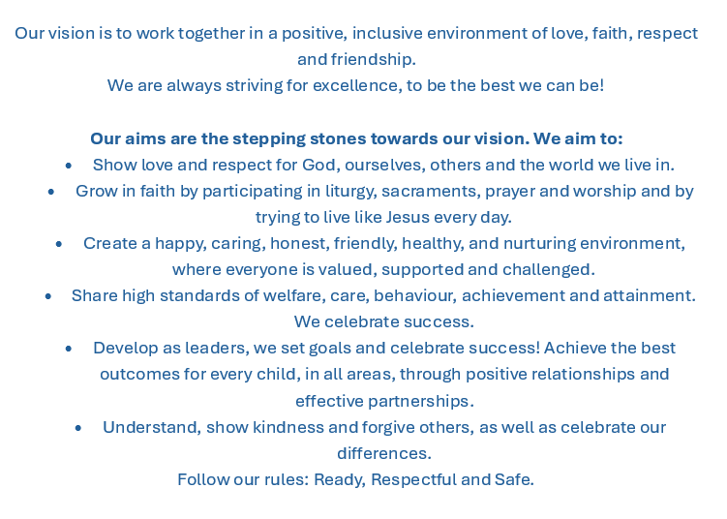
School Vision

ATTAINMENT AND ACHIEVEMENT
To raise standards of educational attainment for all in school, especially in the core skills of literacy and numeracy, and to achieve better levels in national measures of achievement including examination results.

FRAMEWORK FOR LEARNING
To support and develop the skills of teachers, the self-discipline of pupils and to enhance school environments so that they are conducive to teaching and learning.

INCLUSION AND EQUALITY
To promote equality and help every pupil benefit from education, with particular regard paid to pupils with disabilities and special educational needs, and to Gaelic and other lesser used languages.

VALUES AND CITIZENSHIP
To work with parents to teach pupils respect for self and one another and their interdependence with other members of their neighbourhood and society, and to teach them the duties and responsibilities of citizenship in a democratic society.

LEARNING FOR LIFE
To equip pupils with the foundation skills, attitudes and expectations necessary to prosper in a changing society, and to encourage creativity and ambition.

standards

Attendance

To report a pupil absence, please call the school on 01506 652511 or email our office on wlstmarysbath-ps@westlothian.org.uk before 9:30am on the day of absence.

Please help us develop in your child a regular habit of good time keeping. If circumstances arise when your child will be unavoidably late please provide a note of explanation.

The school enters pupil absence electronically using codes for particular reasons for absence. To ensure an accurate record is kept it is important that, should your child be absent, you provide an explanation for that absence either by letter or by telephone. Our school has a system which sends out an automated text message to a mobile telephone in cases of unexplained absence. The text is repeated regularly until answered. Parents/carers and schools must work in partnership in order to benefit from early notification of unexplained absence from school. Parents are urged to opt into this system.

The Scottish government has issued a directive informing local authorities that, due to the impact absences during term-time have on children’s learning, any such absences will be recorded as unauthorised. Family holidays should therefore be taken out-with term times. If, in exceptional circumstances, you wish to take your children out of school, you must make your request to the Head Teacher in writing.

If you become aware that your child may be absent from school for a considerable length of time, due to illness or admission to hospital, you are requested to inform the school as soon as possible.

standards

Ethos and Behaviour

At St. Mary’s P.S we promote a whole school nurturing approach within a supportive and inclusive environment. Central to this are good relationships developed within a positive ethos in a climate of mutual respect and trust based on shared values.

Our approach to promoting positive relationships is rooted in nurture, trauma-informed practice and emotional wellbeing. We recognise that behaviour is a form of communication and at times, can indicate that a child is dysregulated and communicating an unmet need. We help children understand the impact of their actions in ways that are relational, nurturing, inclusive and solutions-focused.

We promote and expect a high standard of responsible behaviour from pupils towards staff, other pupils and towards their surroundings. Self-discipline is the key to good behaviour and we depend on your support in reinforcing the discipline guidelines of the school.

Guided by the Gospel Values and inspired by the example of Jesus Christ, we strive to treat every member of our school community with dignity, compassion, forgiveness and respect, fostering positive relationships where all feel valued, included and supported.

School Dress Code

Each school has its own dress code, for the whole school, based on the Council’s policy which all pupils will be expected to keep to.

Our school colours are royal blue and white and the uniform consists of:
- white shirt and striped school tie or white polo shirt
- grey or black trousers / skirt
- black shoes
- Primary 1 - 6 royal blue sweatshirt or jumper
- Primary 7 navy blue sweatshirt / distinct "7" badge blue blazer

The Council will not be responsible for loss of or damage to pupils’ clothing and personal belongings including mobile phones. Valuable items, including jewellery and unnecessarily expensive articles of clothing, should not be brought to school.

School Clothing Grants are available to parents in receipt of a qualifying benefit; application forms are available from the school or online.

We offer discreet support with uniform through our free uniform bank in our school entrance and through our Family Link Worker.

The Council’s Dress Code for Schools Policy is available online at westlothian.gov.uk.

ethos

Equality and Fairness

All pupils have the right to enjoy opportunities and activities, regardless of their background, race, gender or religion, so that they will be given the freedom to develop their full potential without constraint.

Our aim is promote self-esteem and a positive self-image in every pupil. Self-respect and respect for others is a priority. We treat boys and girls equally and offer the same opportunities to all pupils by offering a diverse curriculum, which addresses the needs and opinions of all. We aim to maintain an environment which is free from bullying, racism and other forms of discriminatory behaviour. We value your support in maintaining this ethos.

Partnership and Communication with Parents

Our School uses the Eduspot app to make home-school communication easier, more effective and more accessible. Eduspot is completely free, and available on the Apple app store or Google play.
- Get instant notifications for new messages from school
- View all updates from connected school systems in one clear timeline.

If you have any children in different schools where Eduspot is also used, you can view messages and information about multiple children with a single login.

West Lothian Schools operate an open, responsive policy with regard to questions or concerns that parents may have. Should you have concerns or complaints regarding the service provided you should raise these with the Head Teacher in the first instance.

Monthly Sways are issued and curricular evenings and Parents’ Meetings are held regularly. Your comments and suggestions on the work done in school and the service provided for you and your child are welcomed.

Evaluation forms will be sent to you from time to time so that we can be sure that we are listening to what you say about the service provided for you and your child.

ethos

Parent Councils

A Parent Council is a group of parents selected by members of the Parent Forum to represent all the parents at a school on a voluntary basis. All parents/carers in a school are automatically members of the Parent Forum of that School.

The purpose of a Parent Council is to:

- support the school in its work with parents
- represent the views of all parents
- encourage links between school, parents, pupils, pre-school groups and the wider community.

Parent Councils operate in accordance with a local constitution. Parents can put themselves forward to be members of the Parent Council in accordance with that constitution.

Further information can be found on the Scottish Parent Teacher Council website http://www.sptc.info

curriculum

General

Every child and young person in Scotland is entitled to experience a broad general education, as described by the Scottish Government’s Curriculum for Excellence.

The curriculum is organised into eight broad categories.

Expressive arts
Includes art and design, dance, drama and music. Your child will get the chance to find out about and express their feelings and emotions and those of others.

Health and wellbeing
Mental, emotional, social and physical wellbeing, planning for choices and changes, PE, activity and sport, food and health, substance misuse and relationships, sexual health and parenthood.

Languages
Includes learning about English as well as learning an additional language.

Mathematics
Includes using real life experiences to make predictions, connect to other things, provide skills to understand and examine information, simplify and solve problems, assess risk and make informed decisions.

Religious and moral education
Includes exploring the world’s major religions as well as views that are non-religious. Your child will think about their own beliefs and values.

Children learn about Christian practice in worship and the place of Christian action in the community. Children will also study other world religions in line with national guidelines.
This part of the curriculum operates through class teaching, assemblies, outside visits and visitors to school.

Any parent who wishes to exercise their right to withdraw their child from religious education/observance should inform the Head Teacher.

Sciences
Includes learning about the natural world and living things, forces, chemical changes and our senses.

Social studies
Includes developing understanding of the world by learning about other people and their values, in different times, places and circumstances.

Technologies
Includes business, computing science, food, textiles, craft, engineering, graphics and applied technologies.

More information about Curriculum for Excellence is available on the Education Scotland website http://www.educationscotland.gov.uk/learningandteaching/thecurriculum

At St Mary’s, we maintain regular communication with parents and carers regarding their child’s learning and progress through a range of approaches. These include termly Snapshot Weeks, during which pupils’ jotters are sent home alongside evaluation forms for both pupils and parents/carers to complete. In addition, we offer parent consultation meetings twice annually, provide annual report cards, and host annual Share the Learning events and school performances. For children in Primary 1 to Primary 3, the Seesaw app is used to share learning experiences and achievements throughout the year. These measures are complemented by our open-door policy, which encourages ongoing dialogue and partnership between home and school.

Instrumental Tuition

The Council offers instruction in bagpipes, brass, percussion, strings and woodwind. Schools will tell children when there is an opportunity to apply for lessons. There is a charge for lessons, but concessions are available. You can find out more from the Instrumental Music Service.

Use of the Internet

Children access information and resources on local and worldwide networks as part of their studies.

We teach children about internet safety and how to report any items that make them feel uncomfortable. We ask parents to promote the responsible and safe use of the internet at home, including the use of social media if parents permit their children to access it.

Further information on safe use of the Internet is available at: http://www.thinkuknow.co.uk/

Assessment and Reporting

Assessment is an integral part of the teaching process and your child will be continually assessed during their school career. This assessment can be both formal and informal and takes many forms; observation, tests, pupil/teacher dialogue, written or spoken tasks and teacher judgement. The result of the assessment process allows teachers to form next steps in your child’s learning.

It is the authority’s policy to also carry out standardised testing in literacy and numeracy at P1-P7. These results form part of the overall assessment information about your child.
Information about your child’s progress will be shared between home and school throughout the session. This will include parents’ nights and an annual report. The aim of the annual report is to provide details of your child’s strengths, development needs and attainment within Curriculum for Excellence. Parents and children are welcome to comment on the annual report.
Parents are welcome to contact their child’s school at any time if they have any questions or concerns regarding their child’s progress.

Support for Learning

Class teachers are continuously assessing the needs of pupils in their class. The authority provides access to Support for Learning staff and resources for pupils requiring additional support.

Should your child require additional support in a particular area you are invited to discuss this with the class teacher. We consult with parents and carers to ensure the needs of children are met. Each school follows the principles of the Scottish Government’s policy of “Getting it Right for Every Child”, for more information see the Scottish Government website.

This authority has a policy of inclusion. This promotes the placement into primary and secondary schools of pupils with significant needs. We consult with parents and carers to ensure the needs of children are met. Each school follows the principles of the Scottish Government’s policy of “Getting it Right for Every Child”, for more information see the Scottish Government website.

Admission Procedures

West Lothian is divided into catchment areas for primary and secondary schools. The catchment areas for all West Lothian Council schools are available online at www.westlothian.gov.uk
Each school is either denominational (linked to a particular religion) or non-denominational (not linked to any particular religion). All the denominational schools in West Lothian are Roman Catholic. Each home address has a catchment denominational school and a catchment non-denominational school, for both primary and secondary education.

The Pupil Placement section deals with all applications for pre-school and wraparound, and deals with applications for the August primary one (P1) and secondary one (S1) intakes. Schools deal with applications for other stages and for P1 and S1 after the pupils start school. To apply for a school, pre-school or wraparound place you must fill in an application form. You can get application forms from schools, nursery schools, libraries, Council Information Service Offices and from the Pupil Placement Section.

To contact the Pupil Placement Section e-mail pupilplacement@westlothian.gov.uk or phone 01506 280000. Information is also available on the Council website www.westlothian.gov.uk

New Entrants to P1

You can apply for a P1 place from the November of the year before your child is due to start school, and the places are allocated in March of the same year that your child is due to start school.

Parents and carers of children who are due to enrol in Primary 1 will be contacted and invited to participate in a comprehensive transition programme. This will include a range of transition events designed to support a smooth and positive start to school, such as multiple visits for pupils to become familiar with the school environment, including the playground, dining hall and classroom. Parents and carers will also be invited to attend information sessions, providing opportunities to learn about school procedures, expectations and ways to support their child’s transition into primary education.

Transfer from P7 to Secondary School

You can apply for an S1 place from the November of the year before your child is due to start secondary school. For more information on admission arrangements please see our website www.westlothian.gov.uk or contact the Pupil Placement Section pupilplacement@westlothian.gov.uk or phone 01506 280000.

Our school works closely with our feeder secondary schools to ensure a smooth and successful transition for Primary 7 pupils. This process includes planned visits to secondary schools, the sharing of relevant information to support continuity in learning and wellbeing, and enhanced transition arrangements for pupils who require additional support. Through close collaboration with colleagues, pupils and families, we aim to ensure that every child feels confident, prepared and supported as they move to the next stage of their educational journey.

Extra-Curricular Activities

Our free Breakfast Club operates five days per week from 8.15am and is open to all pupils. The club is well attended and plays a significant role in supporting positive attendance, punctuality, readiness to learn and wellbeing.

We provide an inclusive Breakfast Club and Lunch Club for pupils attending our nurture provision. These sessions offer a calm, nurturing environment where children can build positive relationships, develop social skills and begin or continue their school day feeling supported, regulated and ready to learn.

In addition, our Family Link Workers facilitate breaktime and lunchtime clubs for pupils who benefit from a quieter, more structured environment during unstructured parts of the school day. By reducing barriers to participation and providing responsive support, these opportunities help children feel safe, included and connected to the wider school community.

Our free after-school club programme, provides children with opportunities to explore new interests, develop existing skills and engage positively with their peers in a safe, supportive and inclusive environment. Clubs run throughout the year on a rotational basis for all year groups and include activities such as football, digital and Lego clubs, multi-sports, and arts and crafts. These provides meaningful opportunities for wider achievement.

health & safety and pupil welfare

Medication in Schools

Most pupils will at some time have a medical condition that may affect their participation in school activities. For many this will be short-term; perhaps finishing prescribed medication even though the child’s doctor regards the child as fit to attend school. Others have medical conditions which, without help, could limit their access to education.

Parents have prime responsibility for their child’s health and should provide schools with information about their child’s medical condition.

Please tell the school if your child needs medication. Forms for any child requiring medicine to be taken during school time are available from the school office or can be downloaded from www.westlothian.gov.uk

Emergency Contacts and Arrangements

It is essential that the school has the name, address and telephone number of an adult to be contacted in case of an accident or your child feeling ill. Please ensure records are kept up to date by notifying the school of any change of address and telephone number of your child’s emergency contact.

Children will only be sent home early in special circumstances. The school will make every effort to contact you in such situations. Where there is no adult to receive the child, they will be supervised in school until such time as suitable arrangements are made. In the event of extreme weather conditions you may check the council website for information on any school closures.

All schools have a means of contacting parents and carers via text message.

health & safety and pupil welfare

Meals and Milk

All pupils of nursery schools and classes are entitled to 0.25 litres of milk daily free of charge. Children whose parents are in receipt of qualifying benefits may also receive milk free of charge. Milk is available to other primary pupils at a reduced cost.

The school dining area is organised as a self-service cafeteria. This area is supervised by members of staff. Children may have school meals regularly or on odd days when necessary. Children choose from three options each day. This usually includes a non-meat meal. A 3 coloured tray system is used - green- usually a packed lunch, red - a hot two-course meal and blue - a snack type meal. These are on display to allow the children to see the choices. The menu is available on the Council website. If your child has special dietary requirements, please let the school know.

All P1-P3 children, and P4-P7 children whose parents are in receipt of qualifying benefits, are entitled to free school meals. Other children can buy a school lunch.

If a child loses or forgets lunch money, we will provide a meal and inform parents of the cost. This amount must be paid the following day.

Some parents prefer their children to have a packed lunch and facilities are provided in the school for the eating of packed lunches.

Further information and application forms for free school meals and milk can be obtained from the school or from the Council’s website www.westlothian.gov.uk.

Security

The school has a security system which allows all doors to be locked electronically once the children are in school. The locking system is released automatically if the fire alarm goes off. All visitors should report to the school office via the front entrance of the school, sign in and collect a visitor’s badge. The school welcomes parents and carers but asks them to help to ensure the security of the school by reporting to the school office.

health & safety and pupil welfare

Photography

West Lothian schools have a photography consent form which is in accordance with data protection and human rights legislation. All parents are asked to sign a consent form before any photographs are taken.

If you have any concerns about photography, please tell the school.

Child Protection Guidelines

The safety of your child at school is a priority for the authority. All West Lothian schools follow the Lothian Child Protection guidelines. A copy can be found on www.westlothian.gov.uk

Playground Supervision

Supervision is provided in the school grounds 20 minutes prior to the school opening, during intervals and the lunch hour. If children have an accident or any other problem in the playground they report initially to the supervisor who will take the necessary action. When pupils are at school, the responsibility for their safety rests with the Local Authority. The Head Teacher and staff undertake this responsibility on behalf of the Local Authority.

Transport

West Lothian Council will provide transport assistance for all primary pupils living more than 1.5 miles from their designated school. The provision of transport for pupils attending special schools and classes is not subject to these limitations, but is based on individual pupil need. Further information can be obtained from School Transport (telephone 01506 775291) or from the School Transport policy on www.westlothian.gov.uk

Parents, who choose to send their children to a school out with their catchment area, will be responsible for any extra travelling expenses incurred.

Car Park

Due to the limited capacity of the school car park, it is primarily reserved for staff, as well as parents, carers and pupils with disabilities or mobility needs that prevent them from accessing the school via alternative entrances. We kindly ask all other visitors to use alternative parking arrangements and thank them for their cooperation in helping to ensure safe and accessible access to the school for those who require it most.

Requested Early Release of Pupil

There are occasions when parents wish their children to be released from school at other than normal closing times, to enable them to keep a dental or medical appointment outside school, or for other reasons. In all cases, a written request must be made for early release. Parents must then call at the school office and their child will be brought to them.

On no account should a child leave school premises on their own.

Data Sharing

On occasion, schools will make data available to partners and also academic institutions to carry out research and statistical analysis. In addition, schools will provide our partners with information they need in order to fulfil their official responsibilities.

The collection, transfer, processing and sharing of data is done in accordance with the Data Protection Act.

Feedback, Concerns and Complaints

If you have feedback, concerns or complaints regarding the service you are receiving, these can be addressed by contacting the Head Teacher in the first instance.

If you are dissatisfied with that response you should contact:

Education Services West Lothian Council
West Lothian Civic Centre Howden South Road Livingston, EH54 6FF
Tel: 01506 281952

Educationcustomerservices@westlothian.gov.uk

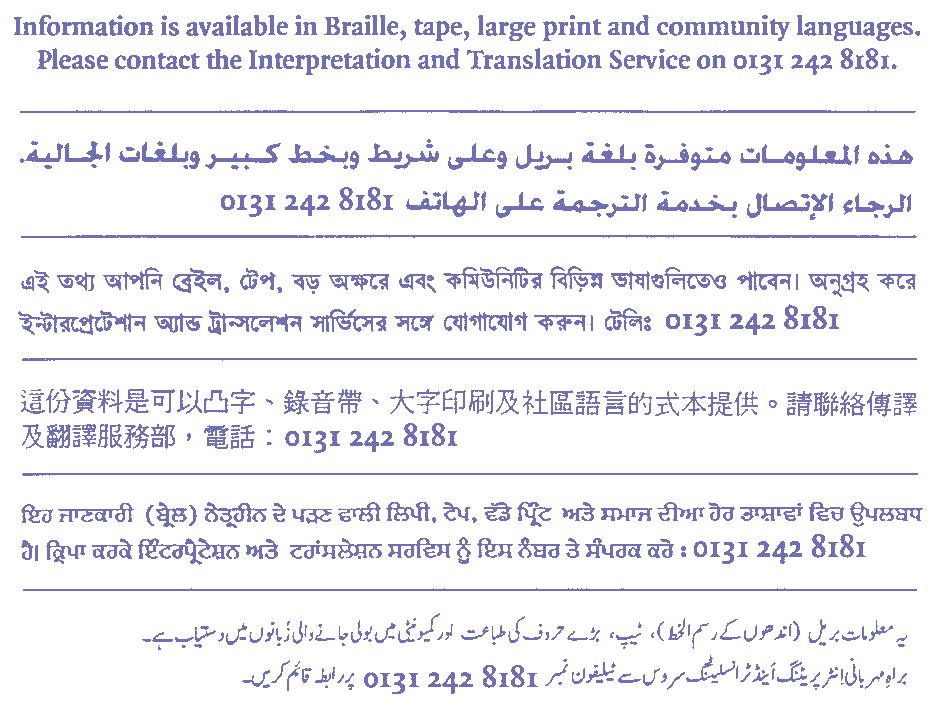
The Complaints Policy and Procedures for Education & Cultural Services is available in booklet form on request or can be downloaded from the web at www.westlothian.gov.uk

